- **local_chern_grid**:

When I was plotting the positions of zero crossings I found that the path through another direction was much more complicated so I can’t tell the local chern number (CL) merely from the zero crossings. Then I realized that I had been focusing on the behavior of small eigenvalues from the start and I forgot the definition of CL should be 1/2*signature(localizer). Thus I plot CL on a quarter of the system at different tc values (sorry it should be h I’ll correct all the notations next time).

-**local_chern_adaptive**:

Similar to **local_chern_grid**, this method helps grasp the whole picture because it is faster than the previous method to find the boundaries between different CL. However it’ll ignore some discrete points.

-**signature_change_origin…**:

The change of CL at origin, just to make sure we have the same critical values obtained from **sigma_change_origin**.

-**energy_distribution**:

This is the spectrum of Halmitonian. Based on the histogram, I set the upper energy bound for the edge states as 0.1.

-**current_Jr**:

This shows J(r) at different tc values. Here J(r) = current * (unit vector of hopping \dot \thetahat) and r is the distance from the midpoint of hopping to origin. For example:



r=1.323 r=0.866

r=1.5 r=0.5

r=0.289

-**how to find the physical representation of critical points (0.960 1.195)**?

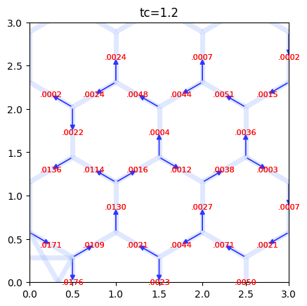I take a look at the current for each edge and found that its direction changes with tc. For example:

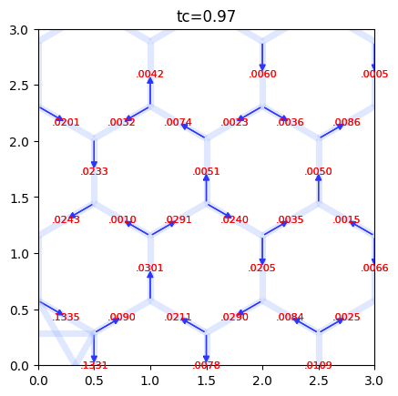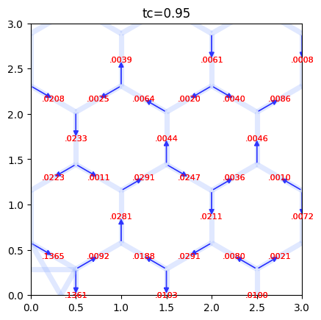

I think one clear observation is the circulation (even though J(r) for completely discrete r doesn’t specifically express circulation) shifts from predominantly clockwise to increasingly counterclockwise, reaching zero eventually.

And in this sketch: the purple edge indicates a change in current direction from tc=0.3 to tc=0.96, orange from tc=0.96 to tc=1.2, red from tc=1.2 to tc=3. But it doesn’t show the magnitude of these changes.

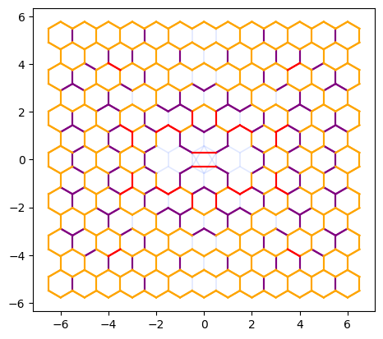

My intuition is that when the central CL=-1 (between tc=0.96 and tc=1.2), the change in circulation might be greater than at other tc values but I’m unsure how to quantify the change in “current circulation” within the closed system.